**Note:**

* **You do not have to match the output 100% to the figures / screenshot.**
* **You must use Abstract Class and Interface in your answer code.**
* **You can use Polymophism (overloading, overriding, etc) in your answer code.**

**Lipopy Winater**

The town's library, named **Lipopy Winater**, is a beloved community hub where residents gather to explore a vast collection of books, magazines, and DVDs. The library is renowned for its unique collection, which includes rare editions and exclusive content curated by local authors and filmmakers. You as a programmer are asked to build the program. There are some requirements that must be fulfilled.

* Main Menu Page
  + This page contains various options that users can choose from.
  + Validate the user input must be between 1 and 6.
  + Navigate user to each respective chosen menu.

Figure 1. Main Menu Page

* Add Item Menu (Menu 1)
  + In this menu, user can insert a new item that belongs to **Lipopy Winater**. To do that, the users need to enter several pieces of information listed below.
    - Title (Validate that the title must at least contain 2 words)
    - Type (Validate that the type must between ‘Book’, ‘Magazine’, and ‘DVD’ [case sensitive])
    - Based on the answer type the user chooses, the user needs to insert different pieces of information listed below.
    - If the user chooses ‘Book’:
      * Author (Validate the author must start with ‘Mr. ’ or ‘Mrs. ’)
      * Genre (Validate the genre must between ‘Fiction’, ‘NonFiction’, ‘ScienceFiction’, ‘Biography’, ‘History’, ‘Poetry’ [case insensitive])

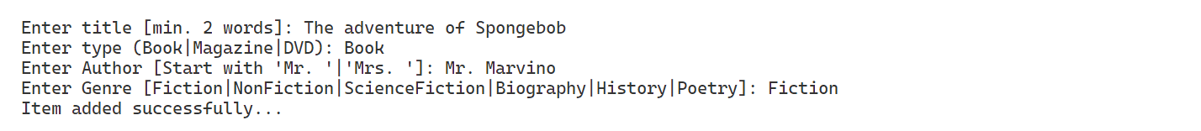

Figure 2. Add Item Menu (Book Version)

* + - If the user chooses ‘Magazine’:
      * Issue Date (Validate issue date must following format [yyyy-MM-dd])
      * Publication Frequency (Validate publication frequency must between ‘Weekly’, ‘Monthly’, ‘Quarterly’, ‘Annually’, and ‘Daily’ [case insensitive])
      * Editor (Validate editor must contains at least 2 words)

Figure 3. Add Item Menu (Magazine Version)

* + - If the user chooses ‘DVD’:
      * Duration (Validate duration must be more than 0 [integer])
      * Director (Validate director must contains at least 2 words)
      * Rating (Validate rating must between 0 and 10 [float])

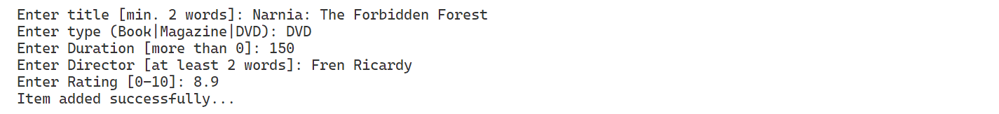

Figure 4. Add Item Menu (DVD Version)

* + - Generate Item ID based on following format:

|  |
| --- |
| XX-YYY-ZZZZZZZZZZZZZZ |

* + - * XX : Taken from first 2 letters from the item type (in capital letter).
      * YYY: Taken from first 3 letters from the title (in capital letter).
      * ZZZZZZZZZZZZZZ: Taken from current time in milliseconds.
    - After the user finishes entering all the information needed, save the information into a list. All new items have a Status attribute with default value AVAILABLE.
* View library items (Menu 2)
  + Validate if the library has any item. If the library doesn’t have any items, display a message.
  + If the library has any items, display all the items’ information.
    - For item with type Book, display:
      * Item ID
      * Item Name
      * Type
      * Author
      * Genre
      * Status
    - For item with type Magazine, display:
      * Item ID
      * Item Name
      * Type
      * Issue Date (with format ‘X, M D Y’)
        + X: Abbreviated weekday name (Sun to Sat)
        + M: Abbreviated month name (Jan to Dec)
        + D: Day of the month as a numeric value (01 to 31)
        + Y: Year as a numeric, 4-digit value
      * Publication Frequency
      * Editor
      * Status
    - For item with type DVD, display:
      * Item ID
      * Item Name
      * Duration (with format ‘X minutes’)
        + X: duration in integer
      * Director
      * Rating (with format ‘X/10’)
        + X: Rating in float
      * Status

Figure 5. View library items

* Reserve items (Menu 3)
  + Validate if the library has any reservable items with status AVAILABLE. Reservable items in the library are only items with type Book and DVD.
  + If the library doesn’t have any reservable items with status AVAILABLE, display a message.
  + If the library has any reservable items with status AVAILABLE, display the ID, Title, and the status of the items.
  + Validate user can only input either ‘exit’ (case insensitive) or item ID that is reservable and with status AVAILABLE.
  + Then change the status of the item into RESERVED.



Figure 6. Reserve items

Figure 7. Item status change after Reserved

* Borrow items(Menu 4)
  + Validate if the library has items with status AVAILABLE or RESERVED.
  + If the library doesn’t have any items with status AVAILABLE or RESERVED, display a message.
  + If the library has any items with status AVAILABLE or RESERVED, display the ID, Title, and the status of the items.
  + Validate user can only input either ‘exit’ (case insensitive) or item ID that is reservable and with status AVAILABLE or RESERVED.
  + Then change the status of the item into BORROWED.

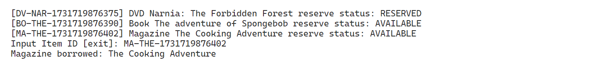

Figure 8. Borrow Items

Figure 9. Item status change after Borrowed

* Return / Cancel Reserve items (Menu 5)
  + Validate if the library has items with status BORROWED or RESERVED.
  + If the library doesn’t have any items with status BORROWED or RESERVED, display a message.
  + If the library has any items with status BORROWED or RESERVED, display the ID, Title, and the status of the items.
  + Validate user can only input either ‘exit’ (case insensitive) or item ID that is reservable and with status BORROWED or RESERVED.
  + If the item’s status is BORROWED, then show the item is returned.



Figure 10. Return Items

Figure 11. Item status change after Returned

* + If the item’s status is RESERVED, then show the item’s reservation is canceled.



Figure 12. Cancel Reservation Items

Figure 13. Item status change after Canceled Reservation

* + Then change the status of the item into AVAILABLE.
* Exit (Menu 6)
  + Terminate the program.